Excel Management Certifications
Excel Management Certifications is one of the pioneer names in the system certification, training & Inspection business. Excel Management Certifications provides system certification according to ISO 9001; ISO 14001; ISO 22000: 2005; OHSAS 18001: 2007, IEC 60079 & other Global certifications worldwide. Excel Management Certifications is also providing IRCA / IEMA approved training courses for these entire standards. Excel Management Certifications is also providing services of Technical product /services Inspection, Verification & Compliance with a competent technical pool of auditors, experts & inspectors.

14001; ISO 22000, ISO 45001 (----CORRECTION

Excel Management Certifications was formed in May 2015 for Quality Management Certification and Consultancy Process. As an experienced certification body, Excel Management Certifications is authorized to assess quality standards.

CORRECT THE ABOVE PARAGRAPHS this is page 1 From ABOUT US

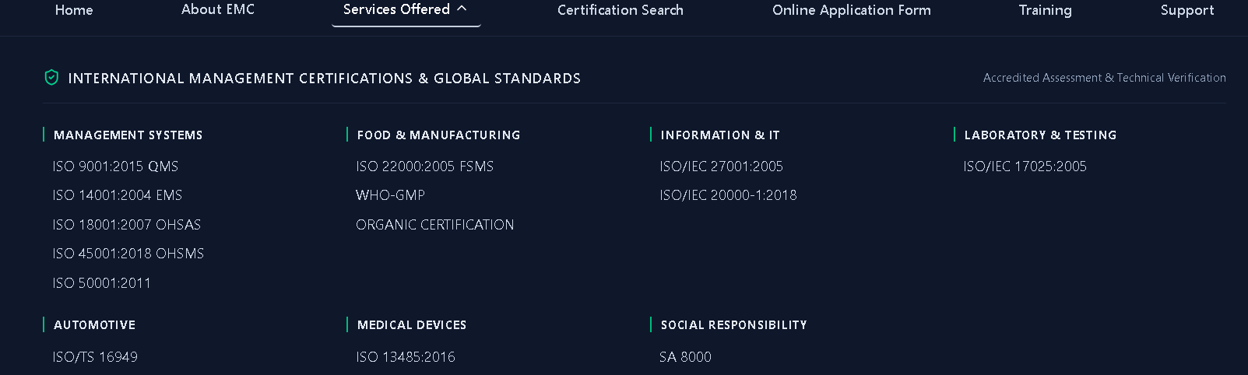
PAGE- 02 Service offered
Correct The Standard and its Year as given below
Correct is;
ISO 9001:2015 ISO 22000:2018 FSMS ISO/IEC 27001:2022
ISO 14001:2018 EMS
ISO 45001:2018 OHSMS
ISO 50001:2018

Correct this on whole site – like standard & year
ISO 9001:2015, ISO 14001:2018, ISO 22000:2018, ISO 45001:2018, ISO/IEC 20000-1:2018,

